**A PROJECT REPORT**

**ON**

**“COAL HANDLING PLANT AND**

**BELT SWAYING IN CHP”**

**By**

**Y. VIJAY KIRAN 09651A03B4**



**DEPARTMENT OF MECHANICAL ENGINEERING**

**ADAMS ENGINEERING COLLEGE**

**Approved by AICTE, New Delhi and Affiliated to JNTUH,**

**PALONCHA, KAMMAM DIST.**

2012

**ABSTRACT**

Coal handling plant is the life –line of a thermal power plant. Since the generation at RSTPS depends solely on the supply of coal from various mines, it is imperative the coal be unloaded efficiently, crushed properly, sent along the conveyer belts quickly as well as be stored in the stock yard as buffer in order to meet unforeseen circumstances.

The department fuel management controls the entire set up of the CHP (Fuel handling) along with the MGR(Fuel Transport). The discussion in this project starts with the fuel transport aspect of fuel management and there after following the path in which coal moves inside the plant.

Belt swaying is crucial factor transporation of coal in a thernal power plant. This report deals with the belt sway and its consequences, its measures using advanced technology and equipment for preventing the swaying of the belt while coal transportation.

**CONTENTS**

1.NTPC A-Maharatna power giant

2.Introduction to NTPC

3.Principle of power generation

a.energy transfer

b.basic principle of power generation

4.Introduction and desriptioof coal handling plant

5.Main location/equipment in chp

a. Track hopper

b. Wagon tippler

c. Paddle feeder

d. Magnetic Separators and Metal Detectors

e. Crusher House

f. Stacker Re-Claimer

g. Conveyer

h. Trippers

6.Conveyor belts

7.History

8.Types of belts

9.Belt swaying

10.Designing of belt

11.Problems caused by belt swaying

12Factors affecting belt sway

13.Measures

a. Pull chord

b. Belt sway switch

c. Zero speed switch

d. Under belt switch

e. Chute blockage switches

17.Advancements

18.Conclusion

19. references

**NTPC - A MAHARTNA POWER GIANT**

NTPC limited was incorporated on 7th November 1975 in central sector as thermal power generating company; with objectives of planning, promoting and organizing an integrated development of thermal power in the country.

NTPC is fuelled with the vision to be a world class integrated power major, powering India’s growth with increasing global presence. It is India’s largest power generation company with an installed capacity of 26,404 MW, with 14 coal based, 7 gas based and 3 joint venture power stations and with 20% of all India’s installed capacity contributes around 28% of country’s power generation. NTPC is poised to become a 75000MW plus Company by 2017.

NTPC limited is the largest thermal power generating company of India. A public sector company, it was incorporated in the year 1975 to accelerate power development in the country as a wholly owned company of the government of India. At present, government of India holds 89.5% of the total equity shares of the company and the balance 10.5% is held by FIIs, domestic banks, public and others. Within a span of 31 years, NTPC has emerged as a truly national power company, with power generation facilities in all the major regions of the country.

NTPC’s share on 31 mar 2007 in the total installed capacity of the country was 20.18% and it is contributed 28.50% of the total power generation of the country during 2006-07. Thus every 4th bulb in the country lit in India is by NTPC power.

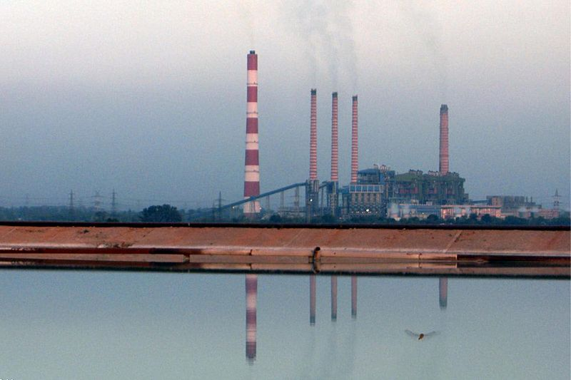

**NATIONAL THERMAL POWER CORPORATION LIMITED**

**[RAMAGUNDAM SUPER THERMAL POWER STATION]**

**INTRODUCTION TO NTPC**

**POWER**

Power is one of the major factors that determine the growth of the nation. For industrialization there is huge requirement of power, for that we require a power plant which is efficient in operation.

Power developed in India began in 1897 when a 200kw hydro station was first commissioned at Darjeeling in 1899. First steam station is at Calcutta of 100kw. There are various sources of energy in India. The power developed in the country was not in systematic and planned manner. Therefore in order to achieve objectives of promoting in India development and rationalization of generation, transmission and distribution of electricity in regional basis through out the country.

But the plans are unfortunately not implemented in meant of collection of monitory aspects as much as possible and successfully.

State electricity boards were constituted in various states of country under the provisions of electricity supply act 1948. There SEB’s were it enjoythe monopoly in the respect of generation. The utilization of existing installed capacity is low.

India has a margin development programmed in which thermal power generation is expected to continue to play a dominant role. **NTPC** has played a vital role in producing power. It has absorbed latest technology in this field from all over the world and has created unique technical organizational which well on the road to attain total in house capability for engineering and construction of large thermal power station with 500mw units and EHU transmission system both AC & DC.

NTPC, a front runner in indian power sector and one of the largest and best utilities in the world. National Thermal Power Corporation Limited (NTPC) is largest thermal power generating company of India. A public sector company, it was incorporated in the year 1975 to accelerate power development of India. The Forbes global 2000 ranking for 2005 ranks it as the 5th leading company in the world. It is a public listed (Bombay Stock Exchange) Indian public sector company, with majority shares owned by government of India. At present, Government of India holds 89.5% of the total equity shares of the company and the balance 10.5% are held by FIIs, domestic banks, public and others. NTPC ranks amongst top five companies, in terms of market capitalization. Within a span of 31 years, NTPC has emerged as a truly national power company, with power generating facilities in all the major regions of the country.

NTPC’s core business is engineering, construction and operation of power generating plants. It also provides consultancy in the area of power plant constructions and power generation to companies in India and abroad. As on date the installed capacity of NTPC is 27,904 MW through its coal based (22,895MW), 7 gas based (3,955MW) and 4 joint venture projects (1,054MW).NTPC acquired 50% equity of the SAIL power supply corporation Ltd.(SPSCL). This JV company operates the captive power plants of Durgapur (120MW), Rourkela (120MW) and Bhilai (74MW). NTPC also has 28.33% stake in Ratnagiri Gas& power Private Limited (RGPPL) a joint venture company between NTPC, GAIL, Indian Financial Institutions and Maharashtra SEB Holding Co. Ltd. The present capacity of RGPPL is 740 MW.

NTPC is committed to the environment generating power at minimal environmental cost and preserving the ecology in the vicinity of the plants. NTPC has undertaken massive afforest ration in the vicinity of its plants. Plantation has increased forest area and reduced barren land. The massive afforest ration by NTPC in and around its Ramagundam power station (2600MW) has contributed reducing the temperature in the areas by about 3c. NTPC has also taken proactive steps for ash utilization. In 1991, it set up Ash Utilization Division to manage efficient use of ash produced at its coal stations. This quality of ash produced is ideal for use in cement, concrete, cellular concrete, building material.

Recognizing its excellent performance and vast potential, Government of India has identified NTPC as one of the jewels of the public sector ‘***Maharatnas***’ – global potential giant. Inspired by its glorious past and vibrant present, NTPC is well on its way to realize its vision of being “A World class integrated power major, powering India’s growth, with increasing global presence”.

**PRINCIPLE OF POWER GENERATION**

It is known for ages that when coal is burnt it releases heat energy. The same phenomenon chemically represented as

C + O2 → CO2 + Heat Energy (395 KJ/Mole)

**ENERGY TRANSFER:**

In the boiler chemical energy of fuel is converted into thermal energy by heating water and converting it into steam. The steam produced in the turbine where thermal energy is converted to kinetic energy.

As the steams expands it rotates the turbine this motion of turbine is transmitted to generator in which mechanical energy is converted into electrical energy, which is transmitted to various load centres through transmission lines.

In this process of generation of power, the following conversion takes place before the chemical energy in the form of coal converted to electrical energy.

**Coal →Chemical energy → Heat energy → Kinetic energy →Mechanical energy → Electrical energy**

**THE BASIC PRINCIPLE OF POWER GENERATION**

A thermal power station works on the basic principle that heat liberated by burning fuel is converted into mechanical work by means of a suitable working fluid. The mechanical work is converted into electrical energy by means of generator.

In a steam power station, heat is released by burning fuel this heat is taken up by water, which works as the working fuel. Water is converted into steam as it receives heat in the boiler. The steam then expands in turbine producing mechanical work, which is then converted into electrical energy through a generator. The exhaust steam from turbine is then condensed in the condenser and condensate is thereafter pumped to the boiler where it again receives heat and the cycle is repeated.

The basic theoretical working cycle of a steam power plant on it works is “**RANKINE CYCLE**” the modern steam power plant uses modified Rankine cycle which includes reheating, super heating and regenerative feed water heating.

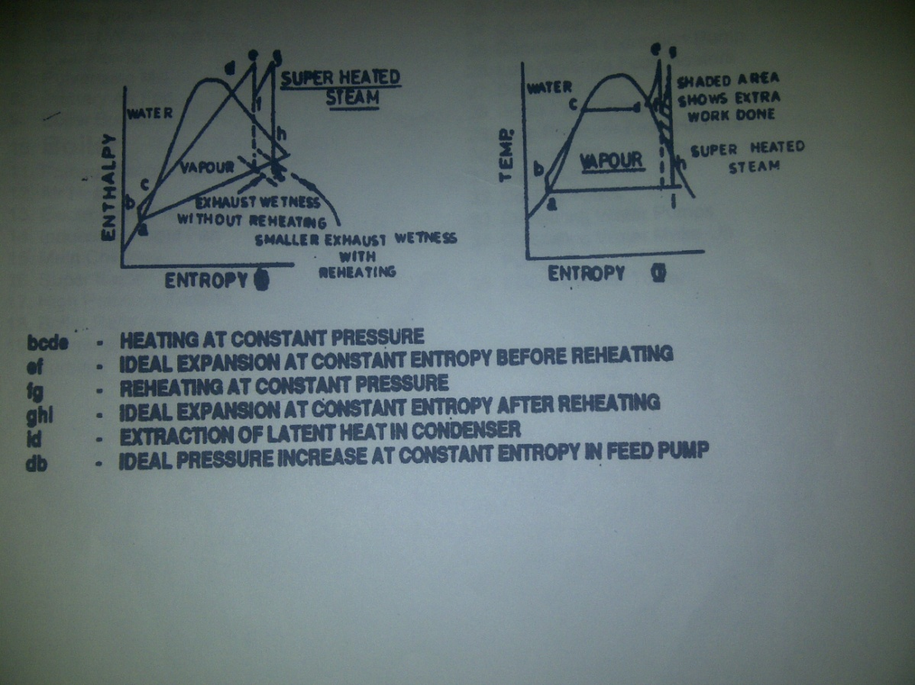

**INTRODUCTION TO COAL HANDLING PLANT**

The purpose of **COAL HANDLING PLANT** in a thermal power plant is to process the raw coal and insure against irregular supply of coal which is dependent on many players in the supply chain. The function of CHP is to receive, process, store, feed the coal bunkers consistently over the entire life of the power plant. Coal Handling Plant is the backbone of a thermal power plant. Now a days it is also referred as Fuel Handling Plant as coal is fuel in thermal power plant.

**Objective**

“The objective of CHP is to supply the quantity of processed coal to bunkers of Coal mills for Boiler operation and to stack the coal to coal stock pile area”.

**DESCRIPTION OF COAL HANDLING PLANT**

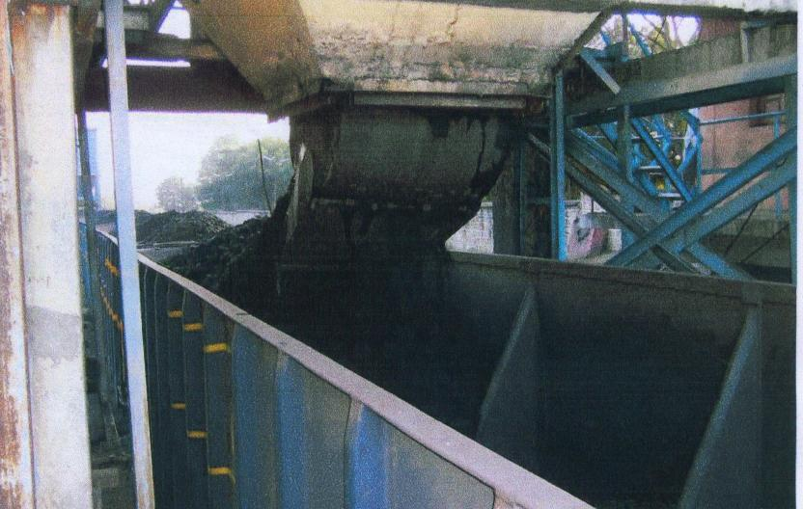

Fuel coal is fed from mines to the boiler through the fuel feeding plant commonly known as “COAL HANDLING PLANT”. Selection of proper methods of coal supply from the coal mines to the power station depends upon the system capacity in tons per hour, location of outside storage and overhead coal bunkers. The transfer of coal takes place by “MERRY GO ROUND SYSTEM” in which loading and unloading will take place within the 12 to 20 minutes. Coal is crushed to the size of 20mm in the crusher house before it is fed to the bunkers of individual units. The coal from CHP is transferred to the bunkers through conveyer belts via transfer points. The storage capacity of bunkers in terms of time is 14 hrs. NTPC Ramagundam requires 40000 MT /day to generate 2600 MW of power.

The coal from the bunkers enters coal mills through coal feeders by gravity action. The quantity of coal reaching the coal mill is controlled by feeders by altering the speed of DC motors as per the requirement of the unit.

**ADVANTAGES OF COAL FUEL**

» Abundantly available in India

» Low cost

» Well developed technology for power generation

» Easy to handle, transport, store and use

**DRAWBACKS OF COAL FUEL**

**»**Low Calorific value

»Large quantity to be handled

»Produces Pollutants, ash

»Disposal of ash is problematic

»Reserves depleting gas

**Constituents of Coal(%):**

|  |  |
| --- | --- |
| Constituent | Percentage(%) |
| Carbon | 36.54 |
| Volatile Matter | 21.6 |
| Moisture | 10 |
| Ash | 32 |
| Conveyor | 0.38 |

**MAIN COMPONENTS/EQUIPMENTS OF CHP**

* Track Hopper
* Wagon Tippler
* Paddle Feeder
* Magnetic Separators and Metal Detectors
* Crusher House
* Stacker Re-Claimer
* Conveyer
* Trippers

**TRACK HOPPER**

One of the unloading point is TRACK HOPPER. It consists of a hopper to dump the coal from wagons. It has a grizzle hopper present at the top to filter and send the coal <200mm size into the hopper. In NTPC Ramagundam there are 2 track hoppers of length 250mand a storage capacity of 4500 metric tons. The main advantage of track hopper system is, coal from the wagons is unloaded within very short period of time less than 5 min.

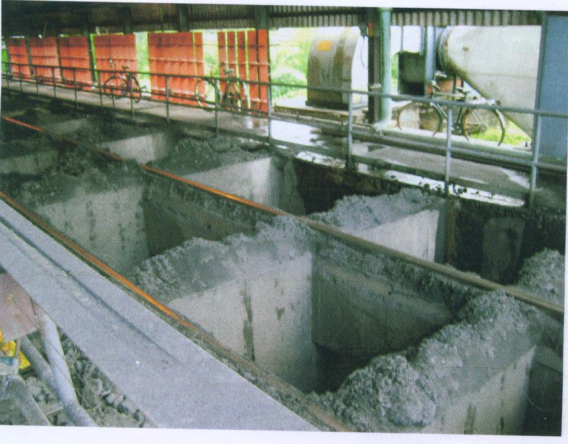

It is used only for BOBR wagons. In this track of length 250m has openings at the bottom similar to the track running on top of a well which is to be filled coal. The specialty of BOBR which allows its usage here is that it contains gates at the bottom i.e., on the wagon floor. The gates can be opened by means of a hydraulic system. Once they are opened all coal in the wagon slides down and falls into the hollow beneath the track which is nothing but the hopper. The hopper can be imagined as a series of inverted funnel shaped structures made of reinforced concrete called CELLS. Track hopper 1 contains 56 cells over a length of 250m whereas track hopper 2 contains 84 cells.

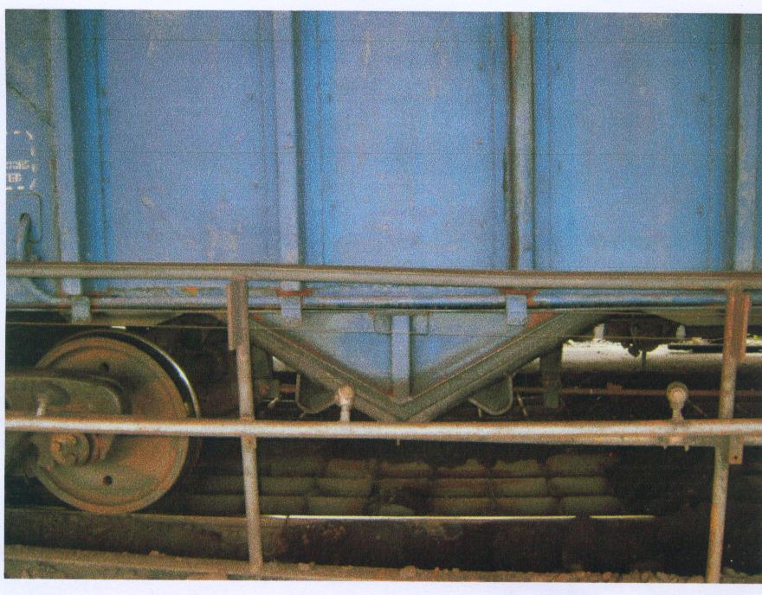

**WAGON TIPPLER**

This type of coal unloading arrangement is done exclusively for the BOX N type wagons. They do not have gates at the bottom like the BOBRs. They do not contain gates on the walls but unload through them would be time consuming and highly inefficient. Hence a machine called WAGON TIPPLER is used. As the name suggests, the machine by means of a hydraulic system tipples a wagon so that all the coal present in it falls into the hopper. The rotary tippler designed for unloading broad-gauge open railway wagon by inverting on its own center of gravity through an angle of 130º, thereby discharging its contents into hopper below rail. It can handle wagons having a gross load up to 110 tons, height from 2,250 mm to 3,735 mm max and a maximum overall width of 3,500 mm. The tippler ensures handling of wagons, without any damage. The tippler consists of two circular rings, a platform with travel rails, support rollers, four C –clamps, which retains the wagon from the top as well as from the side during tippling. In NTPC Ramagundam there are 2 wagon tippler units.

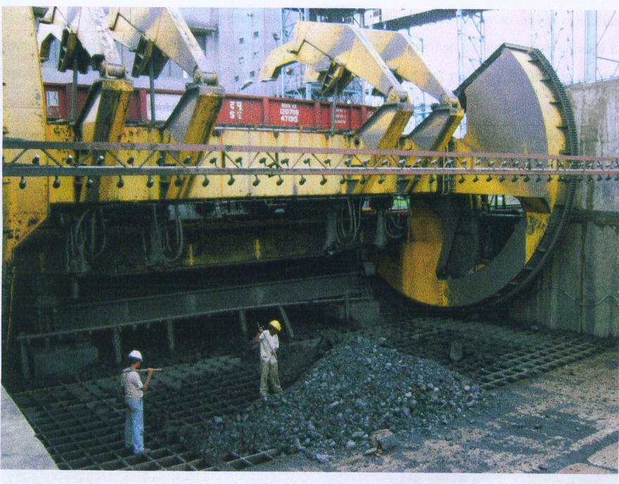

**PADDLE FEEDER**

To remove the coal from the track hopper we use paddle feeders. Paddle feeder is a device which removes the coal from the hopper and send it to the crusher house through conveyer belts.The paddle feeders shall run on rails mounted on the supporting structures of associated conveyors. Both paddle feeder and carriage drives shall be mounted on the feeder carriage. The paddle feeder wheel shall comprise of suitable numbers of vanes with cutting edges. The vanes shall be of high strength steel construction. Vanes shall be easily removable individually. In NTPC Ramagundam there are 4 paddle feeders which have the following specifications

Capacity - 800 TPH(can be regulated as required)

Blades - 6

Speed of paddle shaft - 12 rpm

Drive - Motor-Eddy current coupling-lovejoy coupling-Gearbox-blade shaft

**MAGNETIC SEPERATORS AND METAL DETECTORS**

Coal that is drawn from hoppers is not pure coal. It consists of certain foreign materials like ferrous materials and nonferrous materials. Only coal can be used in boilers to generate steam. Hence it is necessary to remove such foreign metals. Magnetic Separators are used to detect the ferrous metals and remove them from conveyer. It consists of a ferrous metal which acts as a magnet when it is given electricity. It creates magnetic field it is given power supply. The other particles which are not separated by MS are detected by Metal Detectors. Sand bags are dropped when the non-ferrous metals are passed on the conveyer. When the sand bags are dropped the conveyer is stopped automatically and they are removed and then sent for crushing. In NTPC Ramagundam we have 10 MS & MD’s.in addition to this stones are also removed manually by stone pickers.

**CRUSHER HOUSE**

Transforming coal as it is, after it has been unloaded in the hoppers and the tippler is not feasible. Some pieces may be as large as a boulder while others may be as small as a speck of dust. Hence, in order to crush the pieces of coal into nearly uniform size, crusher house comes into the picture. RSTPS has 2 crusher houses : CH-1 & CH-2. Although the basic functioning is same, it has some differences in design. The crusher house is a structure consisting of 5 stores. The top mist level contains the two incoming conveyer belts from the track hoppers and the wagon tipplers. Coal enters the crusher house at this very level and drops into steel structures called CHUTES. In case of CH-1, coal from both the conveyer belts drop into a single chute called the common chute. While in CH-2 each conveyer discharges into a separate chute. Each crusher house contains 4 crushers of hammer type present on the third level. The fourth level contains the chute as well as the **RACK & PINION GATES** to divert the coal into individual crushers. Each crusher has a capacity of processing 800 tons of coal per hour. Each crusher is fed by **FEEDERS**. In case of CH -1, there are **VIBRATING FEEDERS** which are nothing but vibrating plates arranged at an angle so that even that coal falls down into the crusher. CH-2 has **VIBRO-GRIZZLY FEEDERS** which is same as the VF but contains a mesh of size 20 mm. The purpose behind this is that the coal which already has the size of less than 20 mm, will by –pass the crusher there by reducing the load on the crushers. The second levelcontains the belt feeder which is nothing but a belt system to convey the crushed soil to the outgoing conveyer belts situated on the ground level. The entire structure is thus called **CRUSHER HOUSE**. The outgoing belts take coal either to the bunkers present in individual units or for **STACKING** at the **STOCK YARD** of coal present in the plant premises. There are 56 hammers arranged on a rotor that has specifically being designed for this purpose. These hammers rotate along with the rotor and crush the coal that is being guided into it by the VFs and VGFs.

As the coal is crushed in the crushes and transferred on conveyors, dust rises which becomes air-borne. **DUST SUPPRESSION SYSTEM** meant to suppress the dust it is air borne, using high velocity water spray through nozzles installed right at the discharge point, has being put into service in the crusher house. Presently, the control of water supply to various spray nozzle headers, control of pump and recirculation is manual. It is observed that manual system needs a lot of attention.

In NTPC Ramagundam there are 2 crusher houses,8 RPG, 2 drives,8 crushers,56-64 hammers/crusher, 2 screen plates and 1 breaker plate/crusher. The specifications are

Capacity - 800 TPH

Speed - 760 rpm

Rotor assembly - 4m in length

Suspension bars - 4 to 8 no

Wt. of Hammer - 34kg (MN Steel)

Power - 360Kw

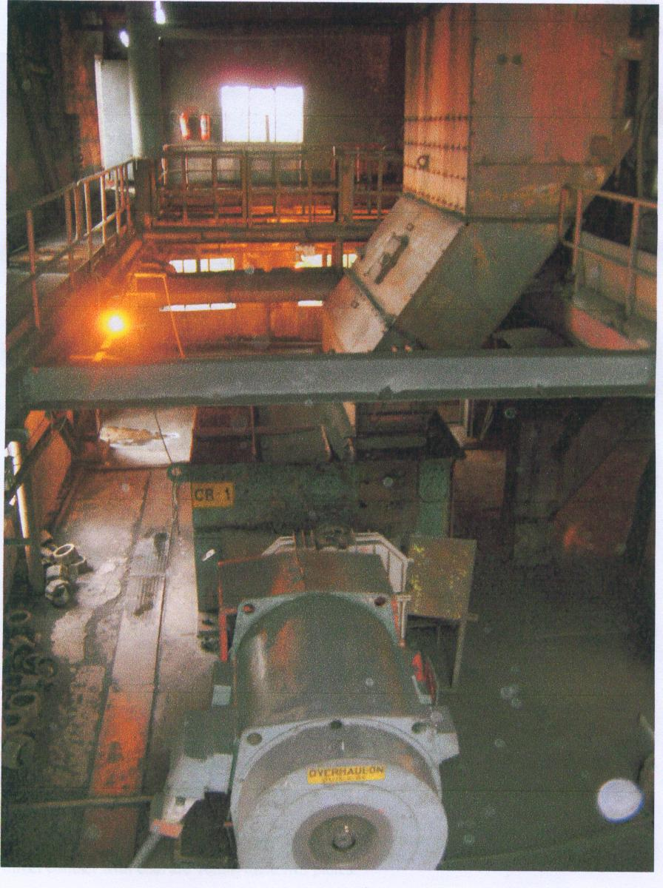

**STACKER cum RECLAIMER**

As the name indicates Stacker cum Reclaimer performs two functions. Stacker-Reclaimer is capable of both stacking and reclaiming complete with adequate length of rail track, cantilever boom conveyor, intermediate conveyor, support carriage with vibrating feeders (if required), boom hoist, reclaimer bucket wheel, control panel, operators cabin, electrical power distribution system, motorised cable reeling drum, adequate length of trailing cables etc in the coal stock yard. In NTPC Ramagundam there is a coal stock yard of 6 lakh tones which is divided into 6 piles. Between every 2 piles a stacker cum reclaimer is placed.

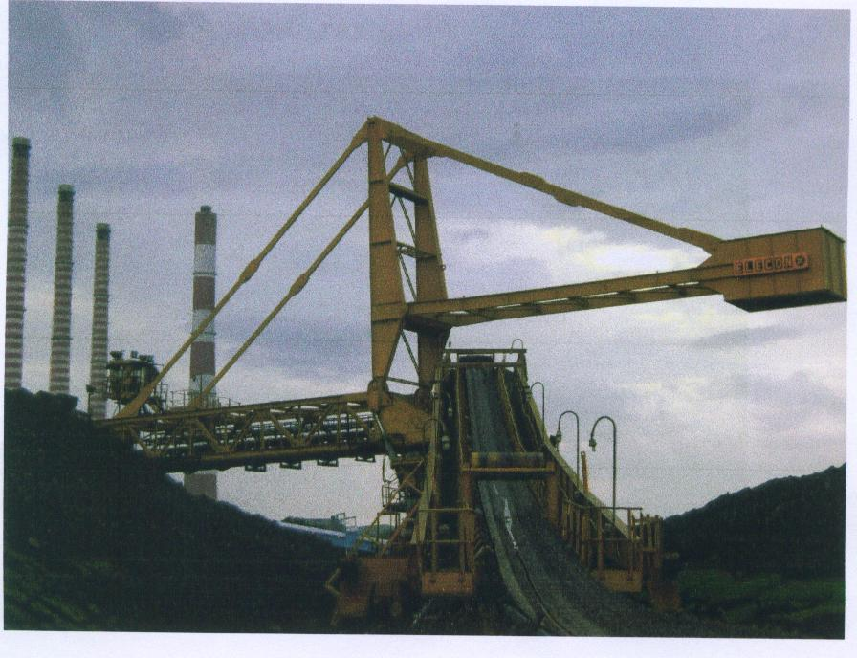

This huge machine has the most imposing presence in the stock yard. Its primary function which handle the coal while it is being added to the stockyard or being retrieved for usage in the bunkers. The stock yard at RSTPS has 6 piles between every two stock piles runs SR along the entire length. The SR runs on rails that are made up of manganese steel alloy and parallel to the length of the pile. The reason while SRs have been popular for bulk material handling is because its movement is three dimensional i.e travelling horizontally on rails, **LUFFING** by moving the boom vertically up and down **SLEWING** by moving the boom in a horizontal plane. During reclaiming mode the job of retrieving coal is done by rotating the buckets arranged in the form of a wheel.

The specifications of the 3 STACKER cum RECLAIMERs are given below:

**Travel Specifications**

Travel Speed - 6 to 20 m/min

Travel Length - 300

Power Rating - 110 KW(as per the requirement)

Speed - 1500 rpm

Coupling - Fluid coupling

Speed Reduction Ratio - 219:1

**Slewing Specifications**

Slewing Angle - ±105º

Speed - 8.32 m/min

Power Rating - 2x10 KW

Motor Speed - 500 to 2000 rpm

Coupling - ELSI coupling

**Luffing Specifications**

Type - hydraulic system

Luffing Range - +10º to -12º with horizontal

Speed - 5 m/min

Stroke Length - 1257 mm

Motor Speed - 3000 rpm

**Bucket wheel specifications**

Reclaiming capacity - 1600 TPH(avg), 2000 TPH(max)

Diameter of bucket wheel - 7.2m

Number of buckets - 10 in SR1&2, 8 in SR3

Capacity of each bucket - 0.65cubic metre

Discharge per minute - 65 buckets

Speed - 6.57rpm

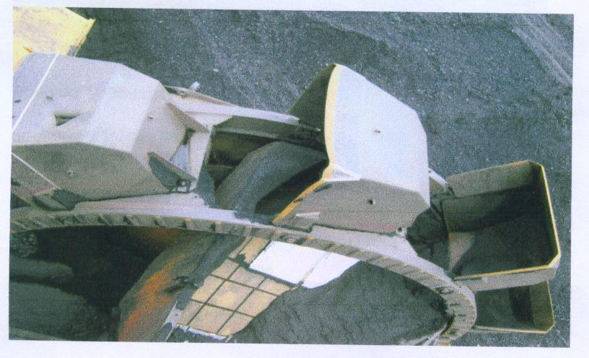

**CONVEYOR BELTS**

Transmission of coal from one point to another point is done by conveyer belts. Conveyor is connected to head (driver) pulley and tail (driven) pulley. It is supported by rollers which are inclined. Conveyors consists of 4 layers which give the required strength. In NTPCRamagundam there are 68 conveyors which comprise a length of 31 km. Of all the other parts if conveyer belts are not present then they are of no use. The specifications of conveyors in NTPC are

Capacity - 1600 TPH

Speed - 3.2m/sec

Power Rating - 180 KW

Belt - EP 630/4, EP 1250/4, EP 1300/4 where EP is Ethylene Polyamide

Troughing Angle - 35º

Take Up Weight - 3 to 5 ton

Drive -Motor-Fluid Coupling-Gear box-GFC-Head pulley-Tail pulley

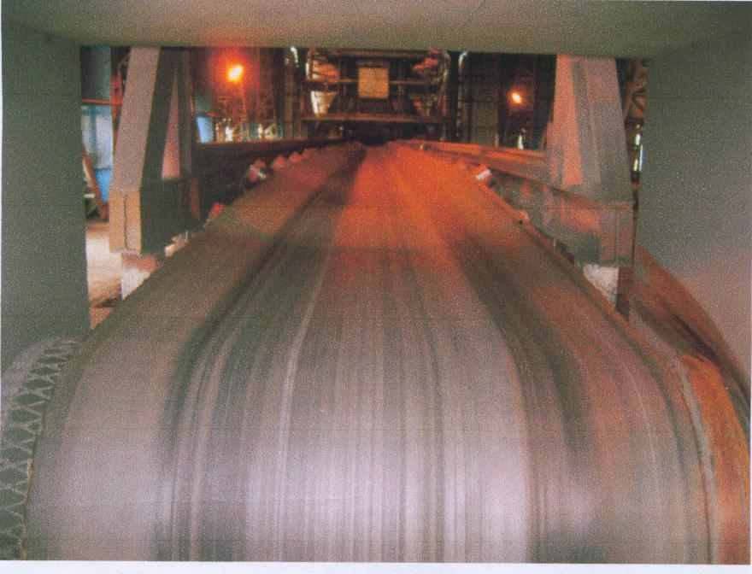

**TRIPPER**

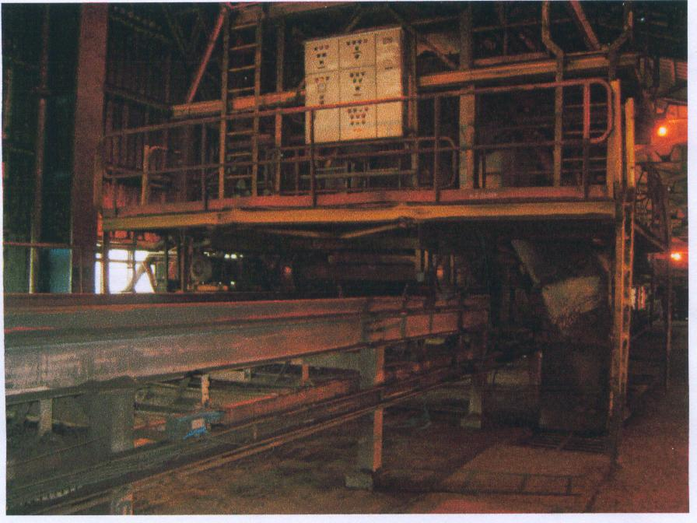

The tripper is provided in the conveyer to stack the material at desired location on either side or along the conveyer with the help of chute/chutes fitted with the tripper itself. The tripper provided with wheels, which moves on rails, parallel to conveyer. These trippers have a rigid welded steel frame to resist shock and minimize distortion. There are mainly three types of trippers. They are

* Motorized tripper
* Belt propelled manually operated tripper
* Winch driven tripper

**CONVEYOR BELT**

A conveyor belt in coal handling plant is used to transport the coal from one point to the other point as per the requirement.A **conveyor belt** (or **belt conveyor**) consists of two or more pulleys with a continuous loop of material - the conveyor belt - that rotates about them. One or both of the pulleys are powered, moving the belt and the material on the belt forward. The powered pulley is called the drive pulley while the unpowered pulley is called the driven pulley. There are two main industrial classes of belt conveyors; those in general [material handling](http://en.wikipedia.org/wiki/Material_handling) such as those moving boxes along inside a factory and [bulk material handling](http://en.wikipedia.org/wiki/Bulk_material_handling) such as those used to transport industrial and agricultural materials, such as grain, coal, ores, etc. generally in outdoor locations. Generally companies providing general material handling type belt conveyors do not provide the conveyors for bulk material handling. In addition there are a number of commercial applications of belt conveyors such as those in [grocery stores](http://en.wikipedia.org/wiki/Grocery_store).



The [belt](http://en.wikipedia.org/wiki/Belt_(mechanical)) consists of four layers of material. They can be made out of [rubber](http://en.wikipedia.org/wiki/Rubber), fibre, here it is made of **ethylene polyamide**. An under layer of material to provide linear strength and shape called a carcass and an over layer called the cover. The carcass is often a cotton or plastic web or mesh. The cover is often various rubber or plastic compounds specified by use of the belt. Covers can be made from more exotic materials for unusual applications such as silicon for heat or gum rubber when traction is essential.

Conveyor technology is also used in [conveyor transport](http://en.wikipedia.org/wiki/Conveyor_transport_(disambiguation)) such as [moving sidewalks](http://en.wikipedia.org/wiki/Moving_sidewalk) or [escalators](http://en.wikipedia.org/wiki/Escalator), as well as on many manufacturing [assembly lines](http://en.wikipedia.org/wiki/Assembly_line). Stores often have conveyor belts at the [check-out counter](http://en.wikipedia.org/wiki/Check-out_counter) to move shopping it.

A wide variety of related conveying machines are available, different as regards principle of operation, means and direction of conveyance, including [screw conveyors](http://en.wikipedia.org/wiki/Screw_conveyor), vibrating conveyors, pneumatic conveyors, the [moving floor](http://en.wikipedia.org/wiki/Moving_floor) system, which uses reciprocating slats to move cargo, and roller conveyor system, which uses a series of powered rollers to convey boxes or [pallets](http://en.wikipedia.org/wiki/Pallet).

**HISTORY**

Primitive conveyor belts were used since the 19th century. In 1892, Thomas Robins began a series of inventions which led to the development of a conveyor belt used for carrying coal, ores and other products. In 1901, [Sandvik](http://en.wikipedia.org/wiki/Sandvik) invented and started the production of [steel](http://en.wikipedia.org/wiki/Steel) conveyor belts. In 1905 [Richard Sutcliffe](http://en.wikipedia.org/wiki/Richard_Sutcliffe) invented the first conveyor belts for use in [coal mines](http://en.wikipedia.org/wiki/Coal_mines) which revolutionized the mining industry. In 1913, [Henry Ford](http://en.wikipedia.org/wiki/Henry_Ford) introduced conveyor-belt assembly lines at [Ford Motor Company](http://en.wikipedia.org/wiki/Ford_Motor_Company)'s Highland Park, Michigan factory. Hyacynthe Marcel Bocchetti was the concept designer. In 1957, the B. F. Goodrich Company patented a conveyor belt that it went on to produce as the Turnover Conveyor Belt System. Incorporating a half-twist, it had the advantage over conventional belts of a longer life because it could expose all of its surface area to wear and tear. In 1963-64, First Indian Small Scale Industrial Unit with Japanese Plant for Rubber Belts for Conveyor was installed near National Capital Territory of Delhi and its MrBelts Conveyor Belting has been widely used in Steel, Cement, Fertilizer, Thermal Power, Sponge Iron Plants and Coal / Mineral establishments / Mines, Port Trusts and similar material handling applications of Industry for the last over 4 decades.

**TYPES OF BELTS**

There are three different types of [conveyor](http://www.wisegeek.com/what-is-a-conveyor.htm) belts:

* Basic belt
* Snake sandwich belt
* Longbelt.

A basic belt conveyor consists of two or more pulleys that hold one continuous length of material. These types of belts can be motorized or require manual effort. As the belt moves forward, all the items on the belt are carried forward.

A common installation sites for conveyor belts include packaging or parcel delivery services. This industry often requires a method of relocating materials from one place to another, quickly and with minimal human intervention. The belt is typically installed at waist height to improve the ergonomics for the staff that are interacting with the materials.

The conveyor structure consists of a metal frame with rollers installed at various intervals along the length of the [conveyorbelt](http://www.wisegeek.com/what-are-conveyor-belts.htm). The belt is typically a smooth, rubberized material that covers the rollers. As the belt moves over the rollers, the items placed on the belt are transferred with a reduced amount of friction, due to the use of multiple rollers. Basic beltconveyors also have curved sections to allow the belt to move product around corners.

**BELT SWAYING**

Shifting of a belt to one side from its mean position while running is called BELT SWAYING.This causes the coal to spill out from the belt. The major problem that arises is the capacity of the transportation of coal through conveyor belts decreases significantly which takes more time to fill the bunkers. The conveyor belts are of very long length which causes the housekeeping problem. It is very difficult to clean and remove the coal along the length of the conveyor. In NTPC Ramagundam, there are 68 conveyors which constitute a total length of 31KM. hence it is necessary for normal running of the belt with acceptable swaying, to transport the required coal. This is also called lining out of the belt. Many factors determine the belt sway. Hence the design of the belt is to be done keeping all the considerations.

**DESIGNING OF BELT**

Belt shall be designed for heavy duty condition and shall be suitable for 24 effective working hours operations per day and 365 working days per year. It shallbe suitable for installation over conveyor system having 35ºtroughingangle and shall be suitable for operation at an ambient temperature of 50ºC. It shall have sufficient resistant against exposure to open sunlight so that its qualities do not deteriorate while working in open sun. Italso may have to work in rain and / or in conditions where relative humidity goes upto 100%.The fabric for belting shall be of Nylon/Nylon heavy duty type. The belting shall be pre-stretched, straight ply, skin coated with open ends. It shall have sufficient strength to give required tension at 10 safety factor and 80% tension utilization. All belts shall be joined by

vulcanized splicing.

**PROBLEMS CAUSED BY BELT SWAYING**

Due to swaying many problems occur running of the belt with acceptable swaying is a crucial factor in fuel management. The problems caused by belt swaying are listed below

* Deviation of belt to a side from its mean position.
* Coal spills out from the belt along it entire length.
* Conveying capacity of the belt decreases significantly thereby causing power loss and wastage of time.
* Due to spillage housekeeping problem occurs which becomes complex to remove the coal along the length of the conveyer.
* Wear and tear of belt occurs which causes the longitudinal or snapping of the belt.

**FACTORS AFFECTING BELT SWAY**

There are many factors affecting the belt sway. All the factors have to be minimized in order to run the belt with the acceptable swaying.

* Cross feeding of the belt which causes the belt to load only at a single place on the conveyor.
* Lagging of the pulley.
* Misalignment in the axial direction of joining the belt. If Centre to centre alignment of the belt is not done this is seen.
* Troughing angle of the rollers in the frame which should vary from 5º to 35º.
* Take up weight which affects the tension. If less take up weight is given it causes the belt to move freely and slipping of the belt .

**MEASURES**

To protect the belt to sway we need to have equipment which improves the belt carrying capacity and helps in the long life of the belt. Some of the equipment are pull chord, belt sway switch, zero speed switch, under belt switch, chute blockage switches.

1. **Pull Chord Switch**

Pull chord type (manually reset type) emergency stop switches shall be located on both sides of belt conveyors along the walkways for the entire length of conveyors for emergency stopping of conveyor at spacing of 30 Meters. The enclosure shall be of cast aluminum with degree of protection IP-65. It shall have a separate terminal box with a separate hinged cover which shall be totally sealed from main box containing actuating mechanism / limit switch etc. Local pull chord actuation shall be provided by means of mechanical flap. Each switch shall have two NO and two NC contacts, which shall be wired out to the terminal block. The terminal block shall have facilities of cable looping. The Contact rating of the switches shall be rated for atleast 5 Amps, breaking at 240 VAC at 0.3 p.f. lagging. Adequate length of rope and all accessories shall be furnished.

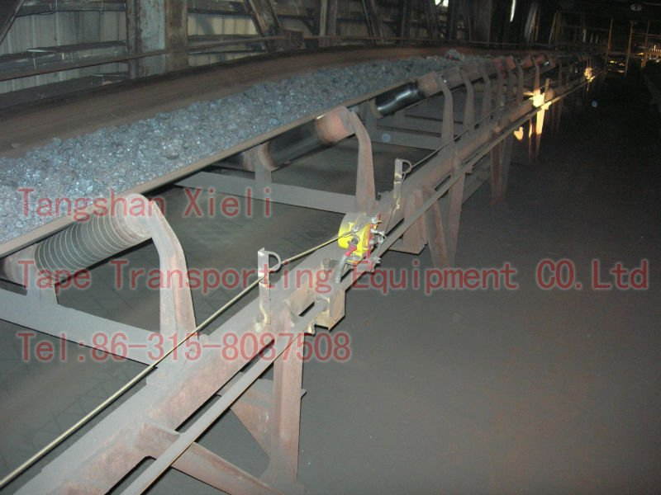

**2. Belt Sway Switches**

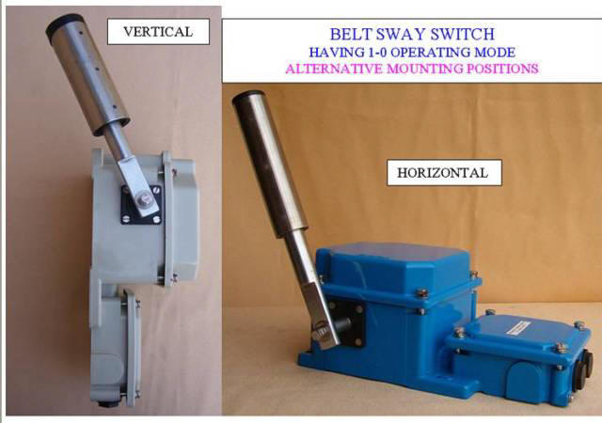

Belt sway switches of self resetting type shall be furnished one pair at 50 meter intervals to limit belt sway to permissible extent. The enclosure shall  be of cast aluminum having degree of protection of IP-65. It shall have a separate terminal box with a separate hinged cover totally sealed from the main box containing actuating mechanism/ limit switch etc. Each switch shall have two NO and two NC contacts one for alarm and one for trip, which shall be wired upto terminal block. The terminal block shall have facilities for cable looping. The contacts of the switches shall be rated for at least 5 Amps. breaking at 240 VAC at 0.3 p.f. lagging.

**3.Zero speed switch**

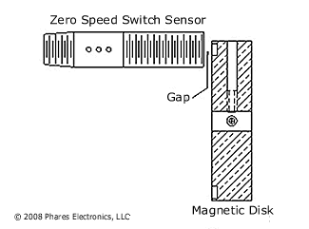

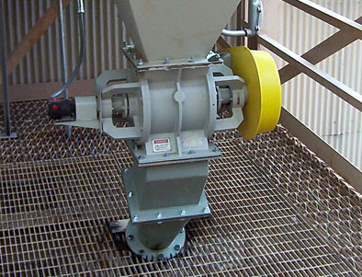

Zero speed switch shall be non-contact (proximity) type electronic switch. Mounting arrangement/ location shall be such that operation, effective sensing distance, sensitivity etc. shall not be effected by accumulation of dust on rotating part or surface of probe. Adequate mechanical protection by means of non-metallic shields shall be provided on top of the switch to prevent any damage due to falling coal / metallic pieces etc. In built initial start up delay and nuisance, tripping delay through timers shall be provided. Each switch shall have two NO and two NC contacts wired out to the terminal blocks. The contact of the switches shall be rated for atleast 5 Amps. Breaking at 240 VAC at 0.3 p.f. lagging. The monitoring unit shall have cast aluminum body having IP-65 degree of protection. A separate terminal box with a separate cover, which shall be totally sealed from main box, shall be provided. Terminal blocks shall be suitable for terminating 1.5 mm sq. standard copper cab.

**4.  Under belt switch**

These switches shall be installed under the belt for detecting the presence of material on the belt whose contacts shall in turn be used for operating solenoid valves of dust suppression system elaborated elsewhere. The switch and its operating arrangement shall be suitable for working in dusty areas. The minimum degree of protection of switch shall be IP-62. The switch shall be capable of detecting three events simultaneously as follows :

i)          Belt loaded

ii)         Belt running at more than preset speed.

iii)        Preset initial start delay.

**5. Chute Blockage Switches**

One no. chute blockage switch of proven type (subject to approval of the Employer) shall be provided at a suitable height on each leg of the conveyors chute nearest to the skirt boards. Chute blockage switch shall trip the feeding conveyor in case of Chute blockage and protect the feeding conveyor equipment.

The switch and its operating arrangement shall be suitable for working in dusty areas.  The minimum degree of protection of switch shall be IP-62.  Local indication of chute blockage switch actuation shall also be provided.  Location of chute block switch shall be such that washing/cleaning of chute by pipe / rod does not affect it.

In addition to the above equipment some of the other preventive measures should be taken. They are

1. Deflector plate should be used to control the direction of flowof coal as per requirement. It should be provided to feed the coal at the Centre of the belt.

2.Troughing angle should be provided for the belt to carry the coal at the Centre of the belt. The belt is flat at the pulley and it should be inclined to help the coal to be at the Centre hence troughing angle should be given and it should increase from 5º to 35º.

3.Belt should be joined axially. If it is not so joined then snapping chances of the belt are more.

4. Idlers should rotate freely. If they are not so then swaying occurs.

5. Self aligned frames should be provided

6. Snub pulley is provided to create maximum angle of contact. If the pulley is not positioned properly then the pulley is of no use. Slipping might occur.

**ADVANCEMENTS**

* Automatic adjustment of the conveyor to correct the sway. Adjustment of the conveyor is the only way to correct the deviation or sway. Motor-Operated adjusted carrier detects the conveyor sway and automatically detects it, greatly reduces the time and cost needed for operation control and maintenance.

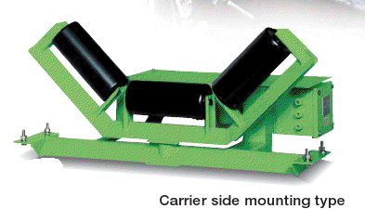

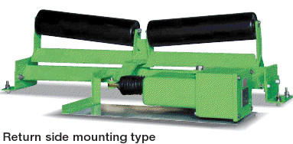

FEAUTURES

* Ideal protection for conveyor belts and material.
* Easy installation and maintenance.
* A much newer design of conveyor belts can be the answer to the frequent cuts and damages it encounters. **STEEL CORD CONVEYOR BELTS**  aresame as the ones used in the current system with the critical difference that it has a layer of steel cords vulcanized with the rubber and interwined with the criss-crossed polymer fabrics resulting in a matrix which has higher tensile strength, flexibility and less prone to damage. Adding to the above properties, they are completely fire resistant by virtue of a layer of non flammable coating over the belt. Also the steel cords are zinc galvanized to prevent corrosion. The combined advantage of all the above is that there is uninterrupted power generation as the coal bunkers are never short of coal.

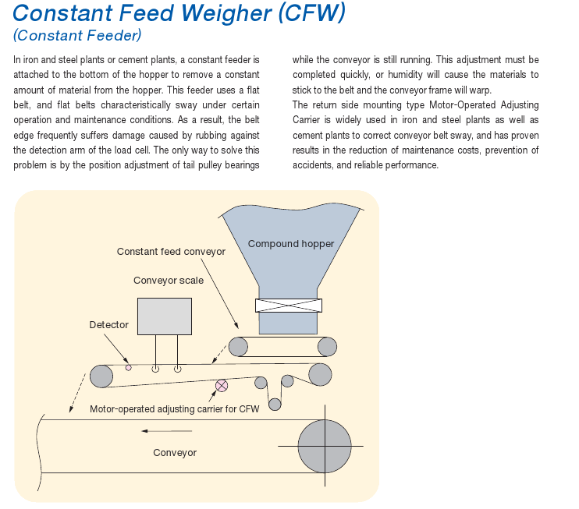

**CONCLUSION**

I have studied about the coal handling maintenance in a thermal power station and belt swaying and its consequences and its preventive measures.

**REFERENCES**

1. [www.wikipedia.net](http://www.wikipedia.net)

2. NTPC reference manuals

3. Godavari intranet